March Madness Predictions Report
Gavin Kafkakis
Introduction
Every March sport lovers from around the country get ready for what is known as one of the most enjoyable postseason tournaments in all of sports. March Madness is known for its twists and turns, and the shear unpredictability of the tournament helps bring people to watch college basketball that have not done so for the entire year. Everyone across the country rushes in March to fill out their bracket in hope to get that perfect bracket or to even just beat their friends, family, or co-workers in their yearly March Madness groups. Every year then, brackets always gets busted by that one team that causes the crazy upset, or the one team that everyone has in the final four that losses in the first round. And every year is the same as we all go and say that next year will be the year, we will create the perfect bracket. What if there was a way to be able to predict a bracket by using historical data to predict trends and then use these trends on the regular season data for the teams making the tournament. Would there then be a way for you to be able to win your bracket pool? To finally be able to predict correctly on the upsets, to predict the teams that will be upset.
Throughout this project, I plan on using data from past March Madness tournaments and March Madness participants along with data from this years tournament to see if there is a way to help predict what will happen in the tournament.

Data
I used data from two different sources, one was from Kaggle that had all of the historical data and data from this year about the tournament teams and the other data set was one that I got from BBallNet, which contained the NET rankings and conferences for teams this season.
2.1 Historical March Madness Data
This data set, from Kaggle, was broken up into multiple CSV’s, I went through each one and decided which datasets that I thought would be beneficial to this project. In the end, I decided to use the data that involved overall conference results from the tournament and the regular season resumes from teaming competing in the tournament. I brought both tables into R to do further analysis and to help figure out if certain factors are going to be beneficial. The reading in of the files I used is included in the project_data.R.
Overall, the data did not have to be cleaned much as there were no missing values in each of the tables. I did not go through and change the structure of any of the variables that I had as I felt each one were good as is. I did go through and null some of the columns and variables that I felt would not be as important in the findings of all of the work that I was doing, this is included in the project_data.R file as well.
2.2 Teams and their conference
One of the main problems that I had with the datasets from the previous section that I got through Kaggle was that on the individual team’s datasets it did not include a column that had that college’s conference in it. I then found the website BBallNet that contained the conference name for each college in the previous year. I then read in that data file using my web crawling skills, the code used for the web crawling is included in the project_data.R file.
The data from the website that I gathered was the college team, conference, NET ranking, and previous NET ranking. The main information that was needed from this dataset was the conference name with the team that will be able to be used in the other datasets. This will help with doing more conference type analysis and combining with the conference results to be able to do more analysis throughout the project.
2.3 Combining the datasets
I was able to bring my two datasets on the ability that both of the datasets will have matching team and college columns. I did a merge onto my resume dataset with the conference information that I gained from the website BBallNet. I also included on with that merge a x.all so that it would include every row from the resume dataset even if it did not have a conference as some teams would move conferences during the years of this dataset. This now left some rows in my dataset that would have missing values because of this merging and teams that did not have conferences.
What I decided to do about that was since the number of these instances was not very high and that many of the teams that did have a missing value for conference, I decided to go and manually fix each of the rows and added the conferences. How I did this is shown in the R file, but I went through first and did a subset to get all of the instances where a row did not have a conference connected to it. This created a new data frame, which I called in the dataset na_subset. I then went and found the conference standings for each of the past years in college basketball on ESPN and used the code seen in the project_data.R file to put a conference in for the teams that did not have conference in the main resume data frame. This then helped me gain a more accurate dataset that allowed for me to do more analysis as a had a full dataset to work from when it came to conferences. I then after went through and got rid of the columns in the new resumes2 dataset that were not relevant anymore. What I found was that my rank, prev, and record were not needed as well as the R-score. The rank, prev, and record were all from 2024 and I had most of the dataset being from years that were not 2024. I also felt that R-score was a variable that I was not going use in my analysis so I felt that it was good enough to just drop it from the dataset.
2.4 Data Dictionary
Team/ School | Character | The name of the school
Year | Date | The year of the tournament
Team no | Integer | The number of the id for the school
Seed | Integer | The seed number the team was in the tournament
Round | Integer | The round that the team made it to
Net RPI | Numeric | Resume metric that will rank teams based on their wins and losses and their strength of schedule
Resume | Numeric | The resume ranking in the nation for that year
ELO | Numeric | A metric to figure out the number of ranked games that have been played
Q1 wins | Numeric | The number of top wins in the country that a team has for that year
Q2 wins | Numeric | The number of wins that are rated by the net as quad 2
Q1 and Q2 wins | Numeric | The total number of quad 1 and quad 2 wins
Q3 and Q4 losses | Numeric | The total of bad losses
Bid type | Character | The type of bid that the team gets to the tournament
Conference | Character | The conference that team is in
B Power | Numeric | Also known as BPI, measures statistics about offense and defense
WAB Rank | Numeric | Known as wins above the bubble, wins against tournament teams
Conference ID | Integer | The id for each individual conference
Games | Numeric | Amount of games played
W | Numeric | Number of wins
L | Numeric | Number of losses
WIN. | Numeric | Winning percentage
R64 | Numeric | Amount of round of 64 losses for conferences
R32 | Numeric | Amount of round of 32 losses for conferences
S16 | Numeric | Amount of sweet 16 losses for conferences
E8 | Numeric | Amount of a Elite 8 losses for conference
F4 | Numeric | Amount of Final Four losses for conferences
F2 | Numeric | Amount of championship losses for conferences
CHAMP | Numeric | Amount of championship winners for conferences

Analysis
All analysis code can be found in the file project_analysis.R
3.1 Predicting Championship Contenders
I wanted to try and find if there were relationships that could have been seen in the past champions in March Madness and if using these trends can help predict the championship contenders for this year. I started by first subseting by resume data table to give me only the tournament champions from the years that are in my dataset. I then went through each one of my variables to figure out if there were trends in the data that can then be brought onto my champion contenders for this year. What I found was that there was no champion in the past 15 years that was above a 7 seed, so for the year 2024 tournament teams, I eliminated all teams that were above a 7 seed. I then went in and found that every champion did not have a NET.RPI that was higher than 22, so I eliminated all teams that were above that level. I then found that all contenders did not have resume metrics that were ranked above 19 in the country. Finally, I went through and saw that every champion had an ELO metric that was lower than 22, so I went through and finally eliminated all of those teams now.
What that brought me was Figure 1, which shows the teams in this year’s tournament that follows the restrictions that have been seen in past champions. The one thing that we can see right away is that our actual champion from this year, Connecticut, is present in this, so we know that at least for this year the champion is among the champion contenders. One thing that looks clear in this is that most of our 1 seeds and 2 seeds are in this data table, which may seem very obvious that they would be champion contenders. In the past 15 years a 1 or 2 seed has been champion 12/15 times, which starts to ask the question of whether this is something that is useful, but when looking into this data more I found a more interesting connection. When looking at our data I saw that every team that was listed as a contender made it at least to the sweet 16, which means that our model was able to predict 10/16 sweet 16 teams, which might be said that it includes all top seeds, so of course they make it out of the first two rounds. However, I saw that it only included two of the four 3 seeds, Creighton and Illinois, and did not include, Kentucky and Baylor. In the tournament, Kentucky was upset in the first round by 14 seed Oakland and Baylor was upset in the second round by 6 seed Clemson. This helps show that our championship contender restrictions are able to pick and choose which top seeds need to be included and which are unnecessary.
In Figure 2 and 3, this compares the past champions to the championship contenders from this season based on two important statistics that will be talked about later, which are B.Power and NET.RPI. As we can see on the scatter plots our championship contenders for this season based on these metrics match up really good when it comes to the past champions, showcasing how each one of these teams are teams that can win it all.
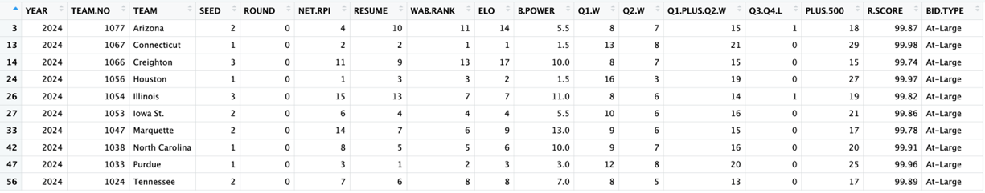
Figure 1 Championship Contenders for 2024 March Madness Tournament
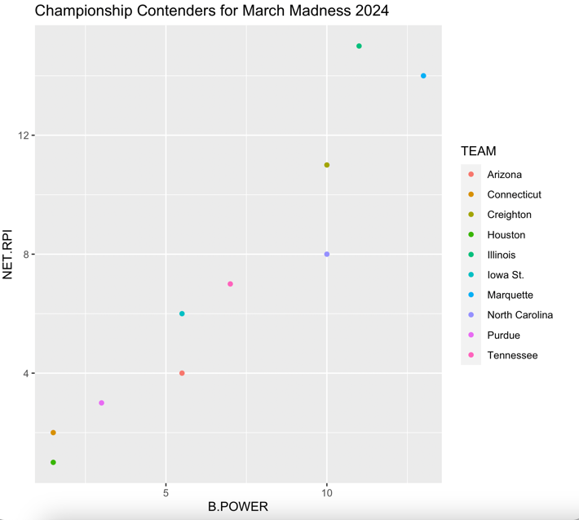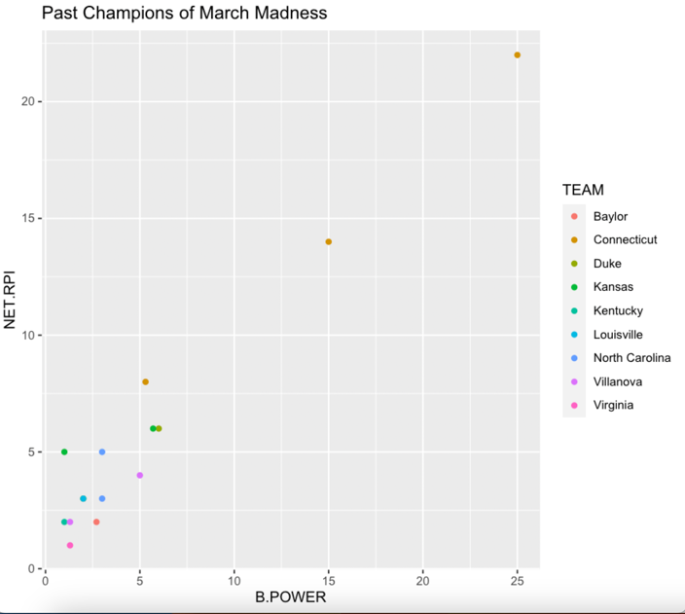
Figure 3, showing past champions based on NET RPI and B Power
Figure 2, showing championship contenders in 2024 based on NET RPI and B Power

3.2 Conference Tournament Results
The next question that I went into was attempting to figure out which conferences were ones that you could trust through March compared to ones that are untrustworthy. To start with this I first looked at my conference results data frame and found some interesting results. I found conferences that would massively overachieve and some that would majorly underachieve. One of the conferences that I found interesting was the Mountain West, or as known in the dataset the MWC.
The Mountain West conference is not among your major conferences but is usually widely known as the one of the best mid major conferences in the country, but according to the data that would not be case. They have gotten 37 teams into the tournament the period from 2008-2023. So, in a 15 year period they are averaging getting a little bit over 2 teams in per tournament, which for mid majors is a great amount. But diving into the data we can that over this 15 year period they are 20-37 in the tournament, with only 6 of those 20 wins coming from teams that were not San Diego State. Which even San Diego State, besides for their championship run from last season, 2023, they haven’t made it past the Sweet 16 even with some very good teams that they have had. The other Mountain West team besides San Diego State have not won a tournament game since 2018, until this year when Boise State finally won one. In that stretch of games the remaining Mountain West teams are 1-15 in the tournament. What this shows is by looking through the data, one of considered top mid majors in college basketball, one that is picked a lot to produce upsets, are almost never winning games in the tournament, besides for San Diego State.
In contrast, one of our better mid majors over the past couple of years has been the Missouri Valley conference, or as known in the dataset MVC. The Missouri Valley is always known usually as a “one bid league”, which just means that they usually only get the conference tournament winner into the tournament. Yet, in 41 games in the last 15 years they have a 21-20 record, which would come out to around a 51% winning percentage the best with our known mid majors. Four of these wins do come from the one tournament run that Loyola Chicago had in that crazy tournament in 2018, but even without that they are constantly winning games. One of the teams in the Missouri Valley that I found extremely interesting was Murray State. In the past 15 years Murray State has been in the tournament 5 times, they have been 4-1 in their first round games in those 5 appearances, including 2 out of those 4 times being double digit seed upsets. These two mid major conferences are among some of the interesting data found from these historic results.
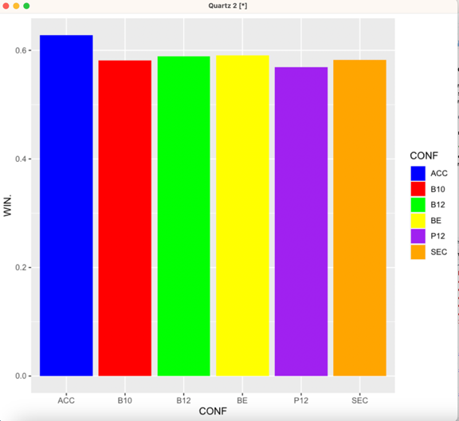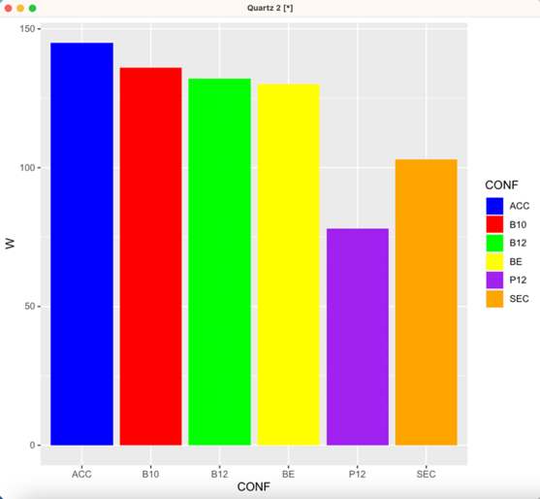
Figure 5 showcasing the top conferences vs amount of wins
Figure 4 showcasing the top 6 conferences vs winning percentage

These two figures above can help us with our knowledge of finding out more about which of our top 6 conferences are the best to follow throughout the tournament. Our top 6 conferences in college basketball include, the Big 10, ACC, SEC, Pac 12, Big East, and Big 12. As seen in Figure 4, the winning percentages are all around the same area, with the ACC having the highest percentage, followed by the next four being right around each other and the Pac 12 being the worst out of them. So, seeing this winning percentage by itself is not a statistic that could help showcase which conferences do best. However, when looking at wins, in Figure 5, it can help give us a much bigger and better picture regarding the conferences. As we can see the ACC has won the most games out of all conferences in college basketball, while also having the highest winning percentage. With that they have also played the second most games out of all conferences, this shows that the conference continually gets teams into the tournament and when that happens, they usually are better suited to go far and wins games out of all of the conferences. Our next 3 conferences are all close together in the Big 10, Big 12, and Big East, these conferences all have around the same amount of the wins, winning percentage, and games played. This shows that these conferences are usually very trustworthy and have a high tendency to make runs throughout the tournament. Our next conference the SEC has a very solid winning percentage, but has not won a lot of games and has not played in a lot of games compared to the rest of the conferences. This can show that teams from the SEC are not always having a lot of teams into the tournament, but also with the lack of games played it can show that they struggle to make runs deep into the tournament. Lastly, the Pac 12 by far our worst power 6 conference, they have the lowest winning percentage, the lowest amount of games played by almost 100 to the ACC, and also have the lowest amount of wins. This means that they lack getting teams into the tournament, even when they do they struggle to win multiple games with the winning percentage so low and the number of wins being so low as well.
After all the analysis throughout this section, I have found that one of if not our best trusted mid major conferences to cause an upset in the first round is a Missouri Valley team, meanwhile, what is widely known as the best mid major conference, the Mountain West is actually a conference that struggles to win games in March. What also was found was that among our best 6 conferences the ACC is the conference that should be trusted the most to go far in tournaments, followed by the Big 10, Big 12, and Big East, meanwhile, the SEC and Pac 12 are conferences that should have the same amount of trust to be able to make far runs in the tournament.
3.3 Team Statistics
My last question that I will go into involves, which team statistics are the most important when it comes to which round a team will be able to make it to. This is something that can help figure out which statistic you should focus on for whether a team will be able to make it far in a tournament or not. This will be done by using linear regression and different correlation tests to find out what matters when it comes to predicting the round.
To start with my analysis, I decided to conduct a linear regression that involved different team statistics from my resume dataset that would be able to help predict which teams would be able to go far in a tournament. The following Figure 6 shows the results of the linear regression on predicting round.
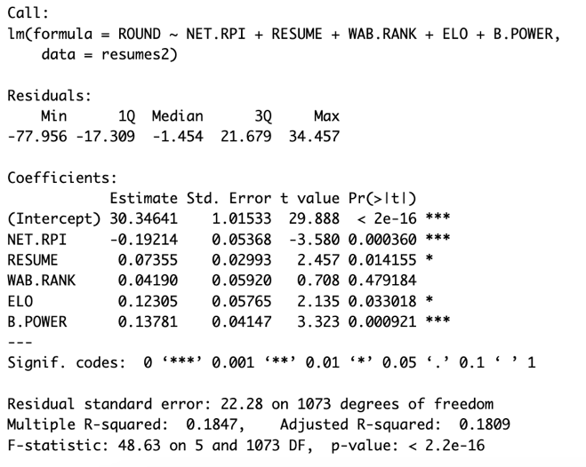
Figure 6, linear regression on predicting round
Since I’m attempting to estimate round that means that the value 64 for the round would be losing in the first round and then 1 would be winning the championship, so you would want this number to be lower instead of higher. For each of these statistics, the lower the ranking that you have the better chance that you have for your round to be lower. Looking at what can be one of our most important statistic first is B.Power. As explained above in the data dictionary, B Power is just the BPI rank for each team in the country, with 1 being the best rating. In a simple explanation BPI, also known as College Basketball Power Index, is a metric that is used to measure how far above or below each average team is, and how good that team can do in the future. The index then uses two measurements to be able to calculate the total BPI, these two measurements are BPI offense and BPI defense. All those statistics are is just the measure of the team’s offense and defense against the average offense and defense. Then the ranking is based on that and the lower your ranking the lower your round will be and each increase in ranking of BPI means a 0.1378 increase in the round that you will be predicted to go to.
The next statistic to look at is an interesting one in Net RPI. By first looking at this regression one could think that a high RPI would mean a lower round, just because this is a negative coefficient. RPI is based on the same scale that the BPI is, which is a ranking where 1 is the best. However, the higher your RPI is the higher the rest of the statistics that are there are going to be, which means that you will lower your round a lot by having a low RPI, but then all of our other statistics would most likely be higher. What this can help show is that the lower the RPI is means that realistically the lower the other statistics would also be. However, one of the most important things to come out this is that RPI can help get rid of a lot of the high ranked RPI teams that have horrible other statistics, or on the other hand showcase a lot of the high RPI teams that have great other statistics. This is a measure that is really significant and can really showcase the teams that the model is predicting to be able to make that far run in the tournament.
One of the best ways to also view this would be through the p-value, this can help show which are significant and which statistics are not. As seen in Figure 6, our B.Power and NET.RPI are our most significant variables when it comes to p-value as they are both the lowest. That helps confirm what I have been talking about from above as they have the largest coefficient difference and have the lowest p-values showcasing how these are two of the most important variables when it comes to predicting the round to which teams can go to.
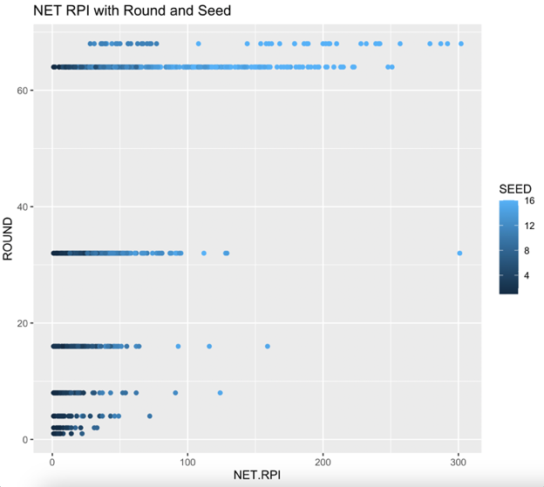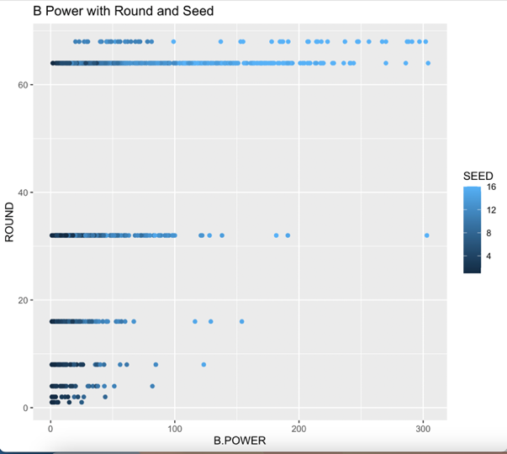
Figure 7, NET RPI and how far in the tournament they made it with their seed
Figure 8, B Power ranking with how far in the tournament they made it with their seed

These two scatter plots above, Figure 7 and 8, really show this in more detail to the NET RPI and the B power are a big indication of teams going far in the tournament. I think that one of the big things that is shown in these graphs is that even for our teams that do upset teams in the first round, besides for very small amounts, they are almost always in the top 100 in BPI and RPI. This helps go to show that you should almost never pick upsets that are outside of these top 100. It also shows that for our Sweet 16 teams, besides for a few outliers, they are also almost always in the top 50. This helps to show that when predicting the tournament and making your bracket, make sure to pay attention to the RPI and the BPI for the teams that you are picking.
Conclusion
Throughout this project I analyzed different factors that could help predict the teams that could be able to make further runs in the tournament. In summary, the following results to the questions that were presented:
- Can we be able to predict the championship contenders based on past data? Do these championship contenders indicate our best teams in the tournament?
There are factors that indicate whether a team can be considered as a championship contender or not. However, these teams are not all going to be considered as locks to be make it far as in some tournaments they do great and others they struggle in.
- Does a the conference that a team is in indicate whether it is more probable to go farther in tournaments?
Yes, I found that the conference that you are in, especially for our power 6 conferences, helps show which conferences get more teams in and how those teams do when they get into the tournament. It was found that the ACC was the most reliable conference in all of college basketball in the tournament over the recent years.
- Is there a resume statistic that is able to help predict whether a team will be able to get to a better round?
Yes, with using linear regression we were able to find that there are resume statistics that are significant when it comes to predicting the round. It was found that RPI and BPI were the best indicators to predicting teams that could go far in a tournament.

This project did have some limitations, which is some of the statistics that are used have been replaced over the years by newer statistics that are being made in college basketball. However, since this is using historical data and trying to analyze from over a larger amount of years, it makes it harder to be able use these newer statistics. If future work were to be done in this idea, it would need to include the newer statistics that can help predict team performance better. This would mean that we would either need to use a smaller dataset that would make predictions not as data backed or wait a couple years until we gather a larger dataset to be able to use the same ideas presented throughout this project.

https://www.kaggle.com/datasets/nishaanamin/march-madness-data
https://bballnet.com/
https://www.ncaa.com/news/basketball-men/article/2019-04-03/march-madness-terms-ncaa-tournament-dictionary

